Aimee’s Audios

Subliminal Acoustic Fingerprinting (SAF) is a new forensic technique that was developed by Amy Holem in 2017. Amy Holem tested her forensic process on over 400 victims of severe criminal activities that break up to 72 federal laws within 1 individual/victim. Analyzing the forensic process with different electronic, computing, recording devices, of videos, audios, and phone conversations, Amy Holem was able to capture and listen to embedded telecommunication within the audio, video, or phone conversation file, of a hidden criminal network.
The forensic process of SAF is subliminal telecommunications that can validate the criminal networks and gather different information for a proper investigation, and capture information on: names of criminals, criminals account information, server information, hacking techniques, equipment being used, companies, departments, services, hosting information, weapons, satellite communications, drones, planes, locations of criminals, places, networks, signals, channels, group networking, file sharing, and other various important information needed for an investigation.
As of today, SAF can prove severe crimes from: stalking, harassment, All Cyber Crimes, child/sex trafficking rings, cyber torture (United Nations: Nils Melzer), torture, sexual/assault, death threats, attempted murder, conspiracy to murder, RICO, video voyeurism, mail tampering, voter interference, social engineering, and over 72 federal/criminal offenses, constitutional right violations, and UN/human right violations/abuses.

Patent: Aimee’s Fingerprint
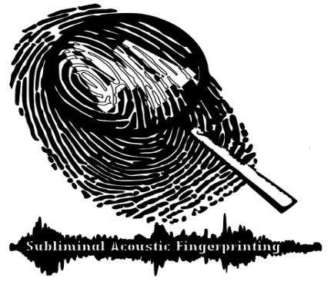
This patent is being developed to live stream and broadcast hidden criminal networks. This includes capturing the criminals communications live/recorded, attacks, EEG, Heart Monitors of attacks, Bio/Sensor information/readings/locations, Pings/trace rts/net stats/ forensic operations that prove hacking, ASN network information, security logs, Micro-doppler radar systems, and more. Please Donate today: only 4,000 left on payments to be released to the public. https://gofund.me/c4552474

